* **Change table –**

|  |  |  |  |  |  |
| --- | --- | --- | --- | --- | --- |
| **Sr.**  **no** | **Change in colour** | **Description** | **suggestion** | **Suggested to** | **remarks** |
| **1.** |  |  |  |  |  |
|  |  |  |  |  |  |
|  |  |  |  |  |  |
|  |  |  |  |  |  |

B.K. Jewellers

**Function Requirement Specification (FRS)**

**Document for**

**“Transfer” part.**

Document NO: 001

Date: 09-02-2020

Prepared by:

Group 2

* **Table of Contents** -

|  |  |
| --- | --- |
| 1. | Introduction |
|  | * 1. Objective |
|  | 1.2 Scope |
|  |  |
| 2. | Functional Description |
|  |  |
| 3. | System hardware |
|  |  |
| 4. | Security |
|  |  |
| 5. | Regulatory requirement |
|  | 5.1 Accurate record generation |
|  | 5.2 Timeouts |
|  | 5.3 Operational system checks |
|  | 5.4 Electronic signature manifestation |
|  | 5.5 User password controls |
|  | 5.5.1 Password expiration |
|  | 5.6 Additional system controls |
|  | 5.6.1 Event logging |
|  | 5.6.2 System access |
|  | 5.6.3 Input checks |

1. **Introduction**
   1. Objective:

This is the functional requirement specification for “location transfer” functionality of **B.K. Jewellers.**

The function requirement specification is details the capabilities and functions that the software must be capable of and reliably perform functionality.

* 1. Scope:

This document applies to the “Location transfer” process of software. The focus is on what the “Location transfer” process must do.

1. **Function description**

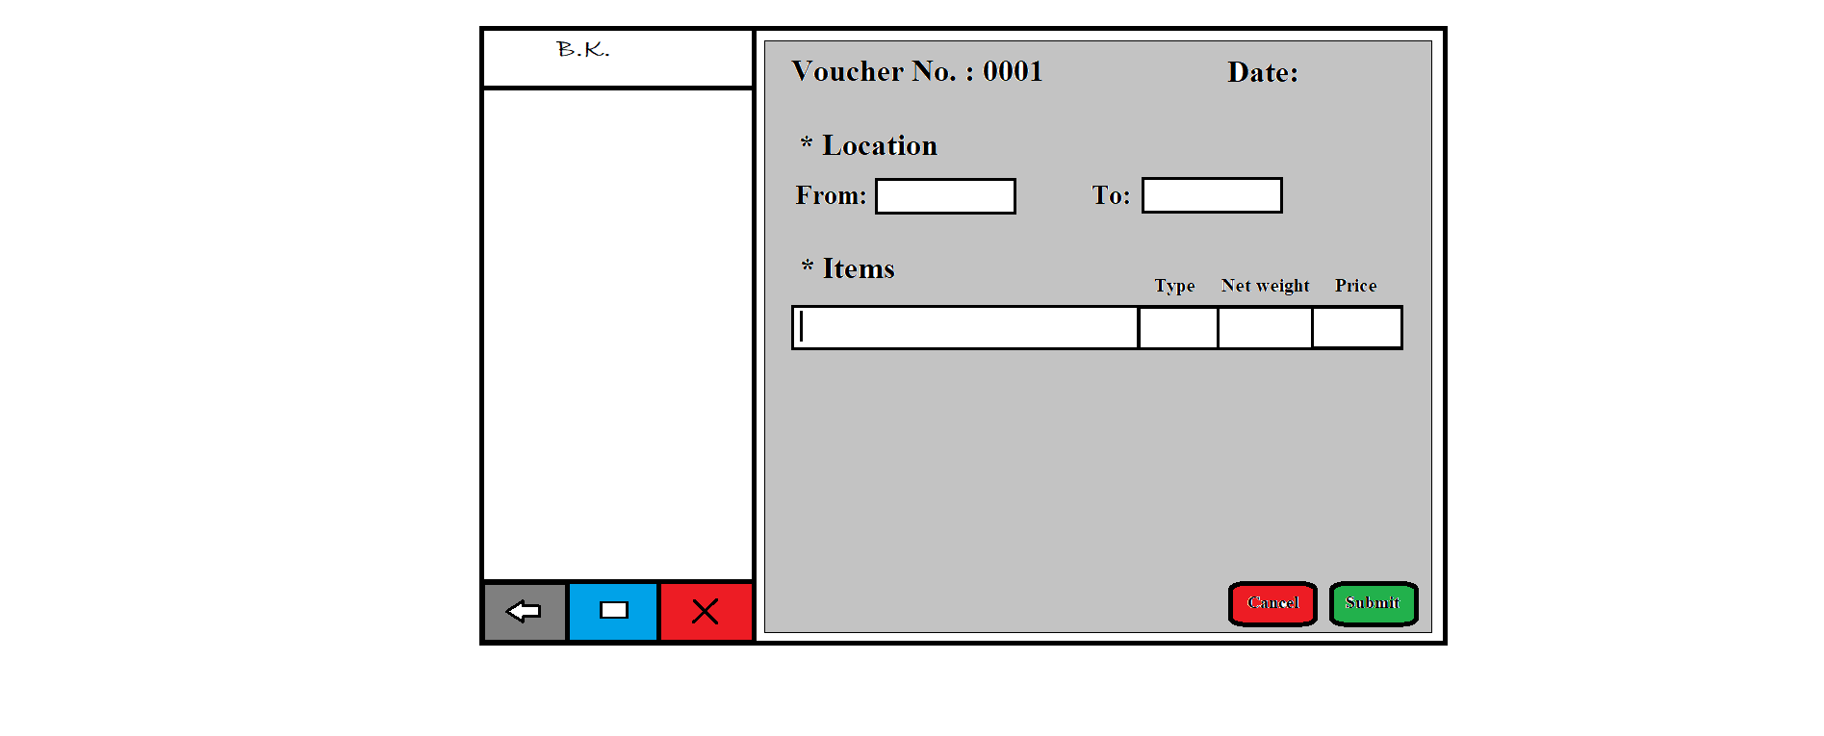

1. Logo

* Type: image
* Use: only for design
* Events: none
* Source: BKlogo.png

1. Voucher No.: *0001*

* Type: text and value
* Text colour: black
* Background colour: gray
* Use: to indicate voucher number.
* Events:

click:- None.

Hover:- None.

* Functions:
* When transfer option is selected software checks number on last submitted voucher and then does an increment by one in it and print after the colon(:).

1. Date:

* Type: text and field
* Text colour: black
* Background colour: gray
* Use: used to indicate current date.
* Events:

click:- None.

Hover:- None.

* Functions:
* When user selects transfer option, software will scan current date and prints in space given after the colon(:).

1. * Location

* Type: text
* Text colour: black
* Background colour: gray
* Use: to give instruction to user for entering senders and receivers location.
* Events:

Click:-None.

Hover:- None.

* Functions:
* None.

1. From:

* Type: text and dropdown
* Text colour: black
* Background colour: gray
* Use: to enter the sender’s location.
* Events:

click:- When click on dropdown list of locations will be appeared.

Hover:- None.

* Functions:
* When user clicks on dropdown, predefined list of location will be displayed and user will have to select one from it.

1. To:

* Type: text and dropdown
* Text colour: black
* Background colour: gray
* Use: to enter the receiver’s location.
* Events:

click:- When click on dropdown list of locations will be appeared.

Hover:- None.

* Functions:
* When user clicks on dropdown, predefined list of location will be displayed and user will have to select one from it.

1. Items

* Type: text
* Text colour: black
* Background colour: gray
* Use: to indicate, start scanning from below.
* Events:

click:- None.

Hover:-None..

* Functions:
* None.

1. 

* Type: input fields
* Background colour: white
* Use: to indicate, place where user starts scanning barcodes.
* Events:

click:- None.

Hover:-None..

* Functions:
* When barcode scanning will be completed for one item the bar-coded data get simplified and show the information (item code).
* After completion of scanning automatic details (type, net- weight and price.) attached with the item will be shown in respective place.
* After the details have been displayed, curser will shift down automatically.

1. Cancel

* Type: button
* Text on button: Cancel
* Text colour: black
* Background colour: red
* Use: to cancel the location transfer process.
* Events:

click:- All entered details will be removed from voucher.

Hover:- display information (text) “cancel” below mouse arrow.

* Functions:
* When button is clicked all entered details will be removed from voucher and user will navigate to respective home page of their software.

1. Submit

* Type: button
* Text on button: Submit
* Text colour: black
* Background colour: green
* Use: to submit the voucher.
* Events:

click:- voucher will get submitted.

Hover:- display information (text) “submit.” below mouse arrow.

* Functions:
* When button is clicked all entered details will be submitted to database and user will see a successful massage “Transfer successful”.

1. **System hardware**

The software can run on the minimum standard PC workstation or laptop configuration by **B.K. Jewellers.** This part can be accessible by all PC present in workgroup of organization for “Sales, Stock management and manufacturing”.

This part of the software does not affect the organization LAN.

1. **Security description**

The sales part is only accessible through the software provided by “BlackSky Systems.” This software or any part of the software does not open from outside the configured environment of **B.K. Jewellers.**

1. **Regulatory requirements**
   1. Accurate record generation:

It has ability to generate accurate and complete record in both human readable and electronic form suitable for inspection & review by regulatory agencies.

The functionality meets the following requirements:

* The ability to generate accurate and complete copies of record in both human readable and electronic form suitable for inspection & review by the agency.
* Users are able to select search queries.
* Users are not able to customise criteria used to view data from search.
* Users are able to export data through MS Excel
  1. Timeouts:

The process for location transfer will not automatically time-out, it is supposed to run after user request till submission.

* 1. Operational system checks:

The location transfer process in software uses operational system checks for enforce permitted sequencing of steps and events.

* 1. Electronic signature manifestation:

The software has secure data in system through electronic signatures. Data secured with an electronic signature cannot be edited or deleted unless the signature is removed.

* 1. User password controls:

This software does not allow user to change their passwords. Only the administration have this authority.

5.5.1 Password expiration:

Once the password is created it never expires unless user requested to change it.

* 1. Additional system controls:

5.6.1 Event logging:

It includes system login and logout, as well as attempts failures.

5.6.2 System access:

Access to software must be controlled by user access to the LAN controlled by system identification and password.

5.6.3 Input checks:

When appropriate entries may programmatically checked before being accepted by software.(for example, No negative values accepted for item price.)